CH-1092 Belmont, Switzerland  Tel +41 21 728-6156, Fax 728-6157  Email info@didel.com, www.didel.com | 
File www.didel.com/slow/mirted/Mir3.doc

MIR3 and MIR4

Many receiver circuits use the 8-pin PIC 12C508 for a saving of cost, weight and space. Differences with larger PICs are not so significant: the 12C508 weights 0.13g but needs a driver and the 40-pin 16F871 weights 0.27g.
Connecting outputs in parallel, and driving them with an appropriate software saves the transistor weight and their expensive soldering.

MIR3 has two channels for 70 Ohm bidirectionnal Birds. In addition, a moter can be controlled with a current of up to one Amp.

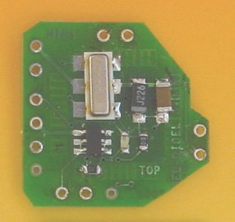 | 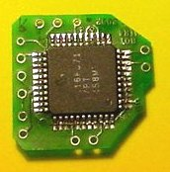 | 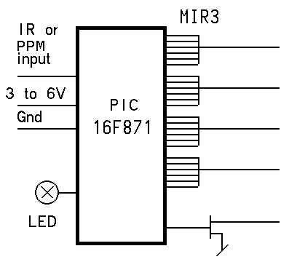

MIR4 has three channels for 70 Ohm bidirectionnal Birds. In addition, a moter can be controlled with a current of up to one Amp. A voltage booster can be used, as shown below.

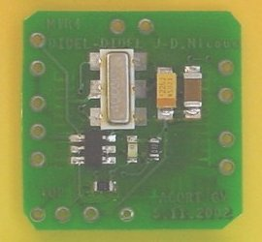 | 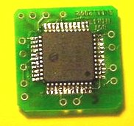 | 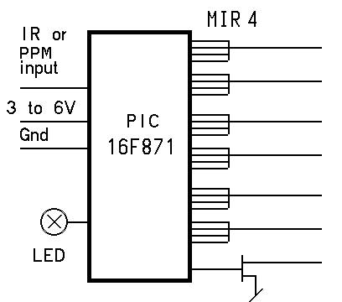

Several processor outputs are bridged to reduce the internal resistance, but there is an important voltage drop on the charge depending on its resistance, but it is much better than that which is used in several controllers based on the 12C508, that are used to control a 200 Ohm Bird from a single pair of outputs.

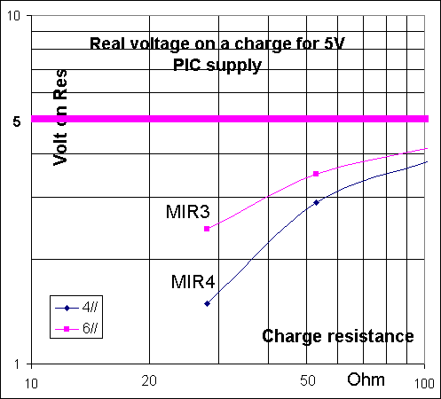 | 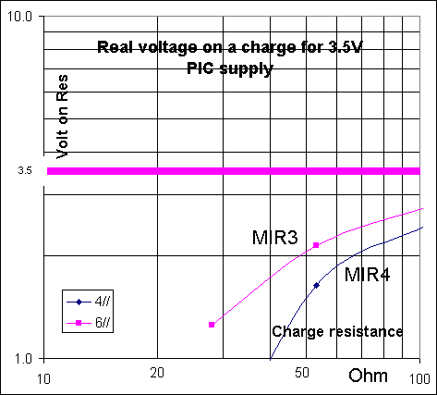

Applications

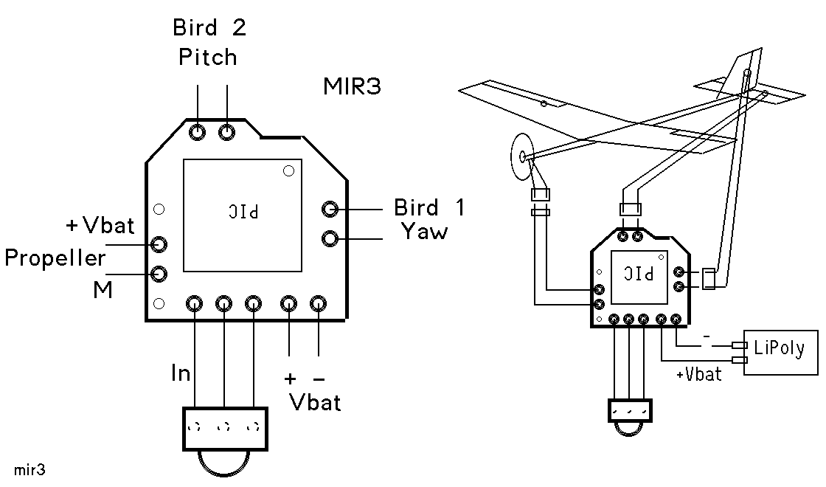

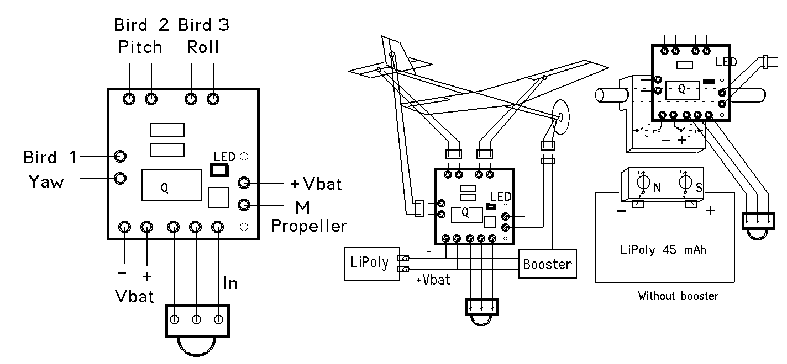

Kit content

MIR3 and MIR4 circuits are delivered with the following accessories:

2 TSOP 1838 IR receiver
4 female connectors
50mm CuBe 0.34mm wire for male connectors
5cm thermo-solderablewire, triple: Gnd green, +V red, signal blue
1 bicolor LED
1 470 Ohm resistor (or 680)
1 SMD 470 nF capacitor and one SMD 390 (or 220) Ohm resistor

Female connectors are cut out of a 64-pin stick of sockets with a pitch of 1.78mm. See www.didel.com/slow/wiring/Plugs.doc for details and see how to do the male connectors.
Thermo-solderable wire has an insulation that melts at 400 degrees. An adjustable hot soldering iron is required.

Preparation

Solder the IR receiver using the colored wires in the correct place. If you use a voltage booster, or if the motor is electrically noisy, it may be necessary to add a filter (4.7uf/330 Ohm) next to TSOP1838.

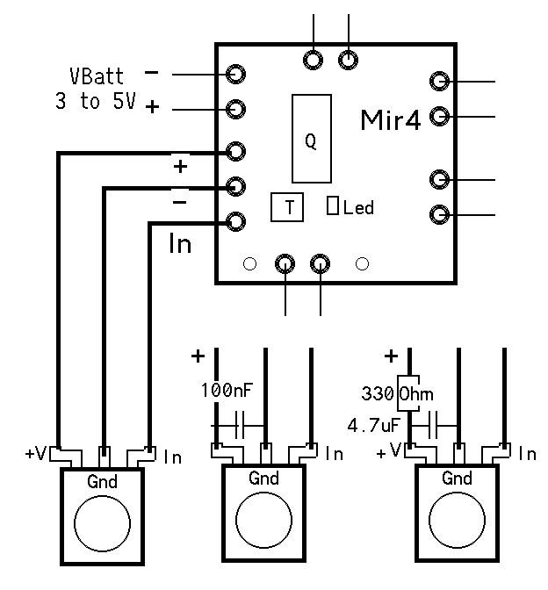 | 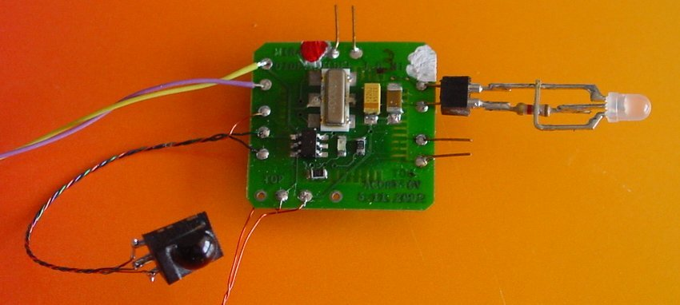

It may be useful, to put a small capacitor next to the TSOP1838. We provide a 100nF capacitor for this.
If you use a voltage booster, or if the motor is electrically noisy, it may be necessary to put a larger capacitor (3.3 uF). The manufacturer recommend a 4.7uf/330 Ohm filter, but this is valid at 5V only.

Testing MIR

Connect a 3 to 5V power supply. The LED on the module must be on (switch off immediately if not the case, the power may be inverted). The LED starts blinking at about 2 Hz as soon a correct IR signal is received. You can already check the reception distance.
Connect the supplied bicolor LED on Bird channel 1; polarity is of no importance. Then it will show a color and intensity that depends on the joystick position. Move the LED to the other Birds output and check the operations are correct. For the moter channel, only one color will show up, since there is no need for a bidirectional action.

The processor blinks the LED if correct IR signals are received. If no signal, LED is continuously ON. If bad transmission, LED will blink irregularily.

If it does not work, double check that the polarity you are applying to the module is correct. Voltage
should be between 3 and 5 Volts. It is safe to have an A-meter connected. In case of excessive current (> 100 mA), switch off immediately and check. The processor should survive a 1-2 second inversion of polarity. A high current may also be due to a transistor with a bad input connection. Both transistors of a push-pull pair are active, and this makes a short between the power supply. Transistors get hot and you can smell it. These small transistors are very robust and they usually survive even if you burn you digit on them. Find the bad connection before continuing.

If a channel does not work, it may be a bad solder. Look at the solders with a watchmaker lens or a binocular. Look specially if there is some space between the component pin and the PC board.

Installing MIR

There are many installation options, depending how the module is fixed to the plane and if connectors are used. We recommend to use the Bahoma system (www.didel.com/slow/magnets/Bahoma.doc) to fix the battery; this avoids a switch and a connector, and is very convenient.

5.03.03/us

