CH-1092 Belmont, Switzerland  Tel +41 21 728-6156, Fax 728-6157  Email info@didel.com, www.didel.com | 
File http://www.didel.com/slow/mirted/EmirPub.doc

EMIR – IR transmitter with battery charger

Thanks to its collaboration with Plantraco (www.plantraco.com), Didel has developed a 4-channel 8-IR diodes transmitter with two joysticks. It is powered by 4 AA batteries.
See http://www.didel.com/slow/mirted/Emir.doc for details

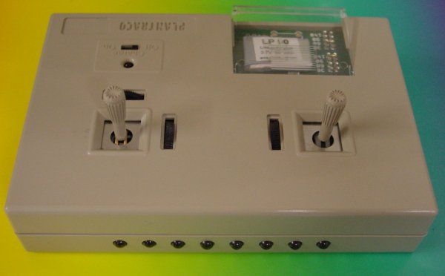

EMIR includes a built-in dual LiPoly Bahoma charger for 20 to 140 mAh batteries.
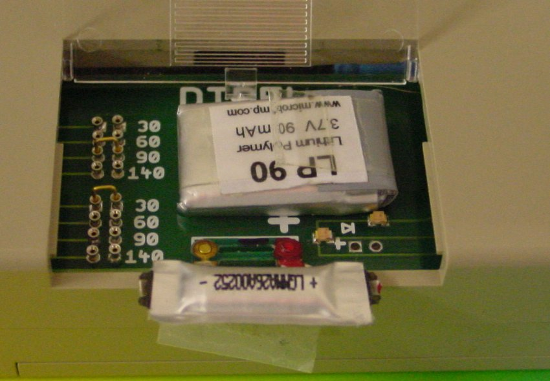

EMIR is available for the price of 140 CHF, about 95 Euros or 120 USD.

Us271204

