CH-1092 Belmont, Switzerland  Tel +41 21 728-6156, Fax 728-6157  Email info@didel.com, www.didel.com | 
File www.didel.com/slow/magnets/BapiLipo.doc

Connecting batteries with Bapi or Bami –sept 2006

Bahoma (battery holding with magnets) is a lightweight and efficient solution for holding batteries on peanut and slow flyer model planes in the 5-20 gram range. LiPoly batteries up to 3 grams can be equipped with gold plated magnets and a matching magnetic connector is fixed on the plane. The additional weight is about 0.16g for the contact pair.  Bahoma is optimized for the new 20 to 140 mAh LiPoly batteries. The pitch is 10mm or 5mm and the 1.5 mm magnets sport a 30g sliding force and 60g axial force. The implementation is facilitated with the small Bapi and Bami printed circuit. |  | 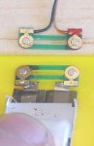 | 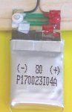
Gold-plated magnets are press-fitted for the best electrical contact. Magnet length has been recently optimized. | 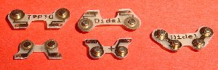

The Bahoma specifications are detailed in the document
www.didel.com/slow/magnets/Bahoma.doc.
Several batteries have been measured in 2005, see
www.didel.com/slow/magnets/TestLipo.doc.

Bapi/Bami-B and Bapi/Bami-M

Initially, as pictured on the top, the –M were supposed to be used fixed on the plane, and the –B on the battery, soldered the easy way. The PCB are the same, but magnet polarity is different.
More compact battery connections are possible with the Bapi-M and users can decide to buy only Bapi/Bami-M. There are four solutions for soldering the PCB on the Lipo. There are two solution for the fuselage, since the –B pieces could also be used on the wrong side (but the magnets does not protrude enough for Plantraco lipo protections. | 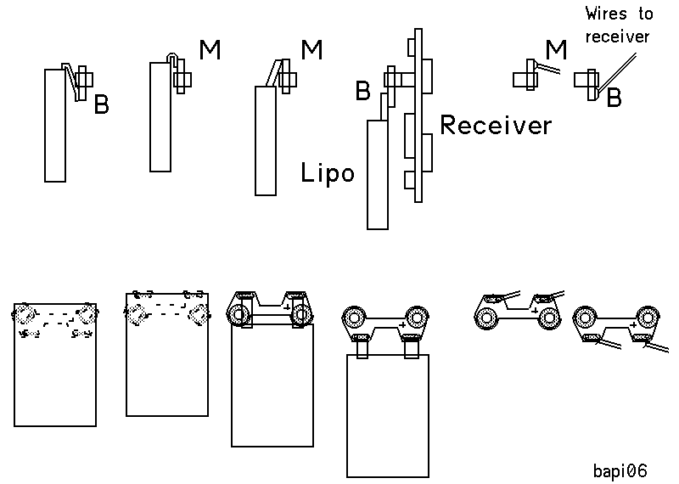

Let us consider the recommended assembly procedure for one solution.

.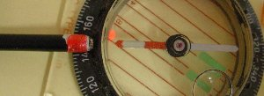 |  | 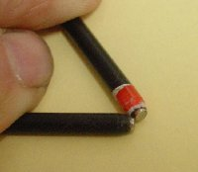
Fist thing is to have a polarity reference.Put a magnet at the end of a stick and paint it in red if it attract the north pole of a compass. To be quite sure, double check with a Plantraco Lipo or a receiver. | 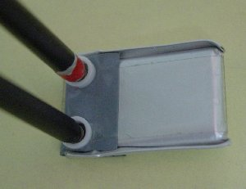 | 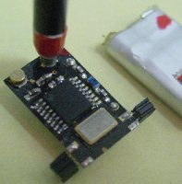 | 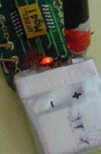

.Second thing is to prepare a block with magnets (or steel tabs) to position and cool the Bapi piece when soldering. Use hard wood, teflon or any insulated material that withstand 200-300 degrees of heat.  Drill 2 holes at 5 or 10mm pitch, of 1.5, 2 or 2.5mm diameter, depending on the magnets you have, and put magnets with the good orientation inside. Red mark when matching the red stick. This correspond also to the plus side of the receiver with a correctly hanging Lipo.  Cut also 3mm strips from a tin box, it will be useful to protect the magnets when soldering. | 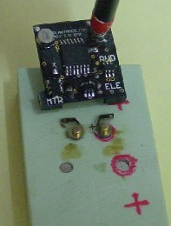

Simple hanging solution  Put the Bapi/Bami-B on the plate, protect the magnet and put small drops of solder on the PCB and on the Lipo. The lipo tabs mut be wet with solder, use flux and never heat for a long time.  Put the pieces in front of each other and heat with the soldering iron.  Align and glue a piece of balsa in ordrer to isolate and consolidate.. |  |  |  | 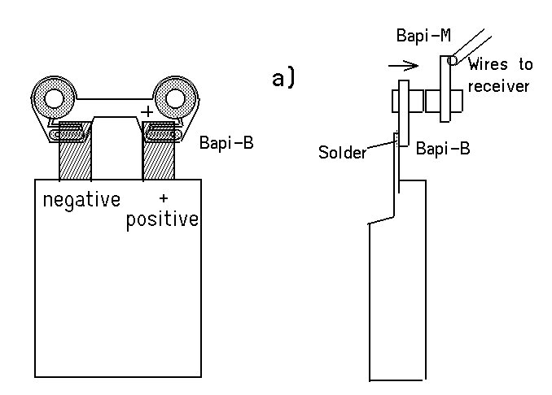
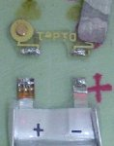 | 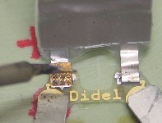 |  |  |  | 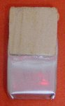

Other solutions
The three solutions presented below are mor compact. Depending on the shape of the Lipo and the position of the tabs, one may prefer one solution or the other. Be carefu with the position of the + on the PCBm, so it corresond to the + of the Lipo. In this case the polarity of the magnets should be good, but double check with the sticks. Do the gluing and reinforcement according to the construction.
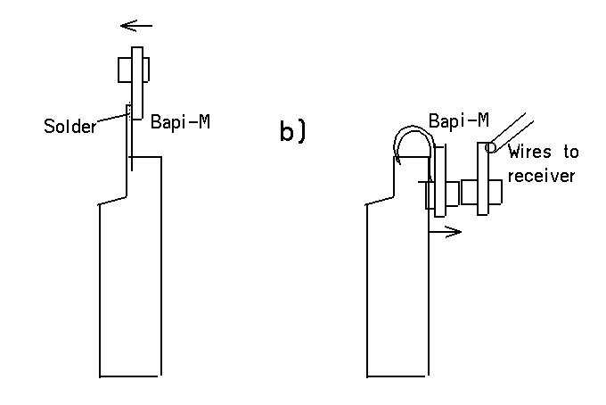 |  | 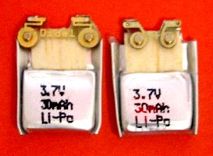
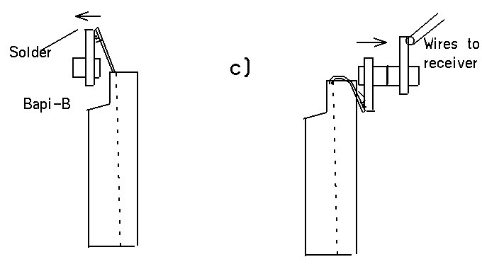 |  | 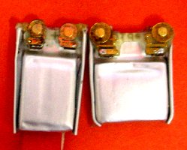
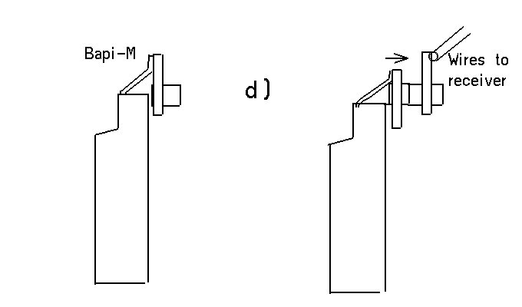 |  | 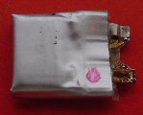 |  |  |  |  | 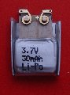

A useful device – Is your Lipo good, is it still loaded?
The voltage drop through a LED is 1.5 to 1.7V, depending the currant, manufacturer and the color. Blue LEDs are 3.4 to 3.7V.
If we put two red or green (preferably) LEDs in serie with a 300 Ohm to 2 kiloOhm resistor, we get some light when the Lipo is good. Not precise, but if the solder is bad or the Lipo fat, we know immediately it has to be fixed or thrown away.
With 1k as a serial resistor and a 3.3 kOhm in parallel with one of the diodes, the diode with the resistor fake before the other.

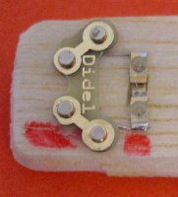 | 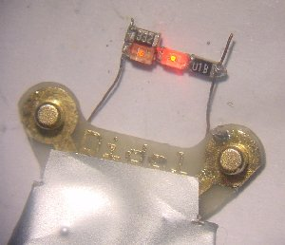 | 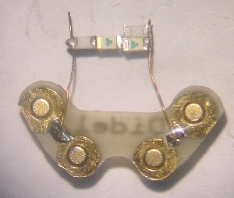
Second part - out of 2004-2005 version

To avoid short-circuits, prepare a piece of cellophane tape 12x15mm and fold 4mm of the long side on itself. The folded part is placed against the magnets, and the tape sticks on the battery. The tape protects the magnets against accidental short-circuits. When the battery has to be inserted, just push aside the tape. | 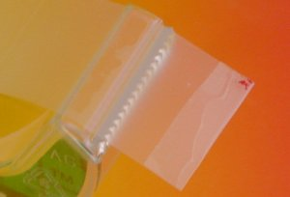 | 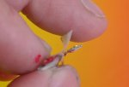

Lipoly 30 mAh

The ABF 30 mAh weights 0.87g, and measures 11 x 17 x 3.5 mm. Its internal resistance is one third of the Kokam 20 mAh.
The tabs are 5mm center distance. We fold them and cut them to be compatible to the 10 mm Bahoma. It is then easy to presolder on the extremity of the tabs (bottom side), and on the Bapi-B (top side). Solder the two togethers and put the red nail paint.
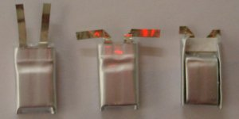 |  | 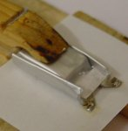
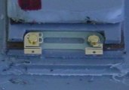 | 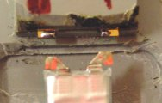 | 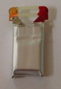

LiPoly 60 mAh

The Kokam 60 mAh Li-Poly weighs 1.90 to 1.95 grams and looks like an 7-8 mm cylinder terminated by two solderable tabs. Adding the Bapi-B and cellophane tape increases the weight by 0.1 gram.

Only one side of the tabs can be soldered. Put a small drop of solder close to the battery and solder two 0.3 to 0.5mm copper wires. Of course, proceed rapidly so the battery will not heat significantly. | 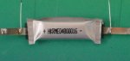 | 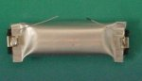
Fold the tab and prepare a Bapi-B with two solder drops, as for the 20 mAh cell. Solder the wire on to the Bapi, it is easy.  Protect the non contact side with red and and white painting. | 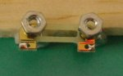 | 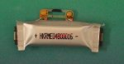

LiPoly 45 and 90 mAh

Only one side of the tabs can be soldered. Put a small drop of solder on the end of the tab and determine how the tab will be attached to the Bapi-B. In some cases, it is necessary to bend the tab by 180 degrees, in order to have the solder on the right side. | 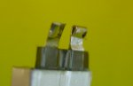
Cut the tab and fold if necessary. Put a small drop of solder at the end of the tab proceeding quickly so the battery will not heat significantly.  You can decide to solder the Bapi-B on the front side of the cell or the back side. Solder on the non contact side of the Bapi-B, and be sure to respect the polarity. | 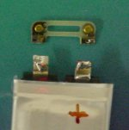 | 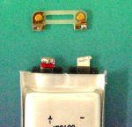

This is a finished 140 mAh Lipo viewed on the contact side. This does not look the best for matching a flat surface (e.g. on the microBlimp) but in practice it is not a problem. | 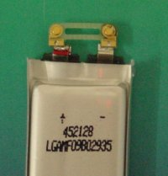 | 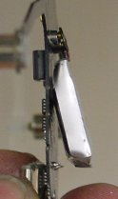

jdn0411046Us 041204 050403

